Phase 3 – Validation of hypotheses with joint data collection

Main issues
Are the bottles the same? Are they bottles with the same composition?
If we accept that they have the same composition, why is there so much variation between the colors we observe? Are there colors that vary more than others?
What results do we obtain if we add together all the data from the bottles that we consider to be the same?
What is the contents of the bottle?

Objectives
Reflect on the variability of observations.
Consolidate calculation strategies with percentages and fractions to calculate a proportional element.
Develop the ability to argue and justify conclusions based on data.
Prepare a final report that includes the entire research process and the conclusions obtained.

Phase structure: main moments, timing and classroom dynamics

[1] Trobar les ampolles equivalents 1 0 minutes
The teacher will again summarize the teams' results in the table on the board, but now they will organize them according to whether blue or pink are more frequent and will pose the question: Are the bottles the same?
The teacher will propose that they do a final data collection, now without making any more visualizations, but assuming the hypothesis that there are only two types of bottles (those with an abundance of blue balls and those with an abundance of pink ones).
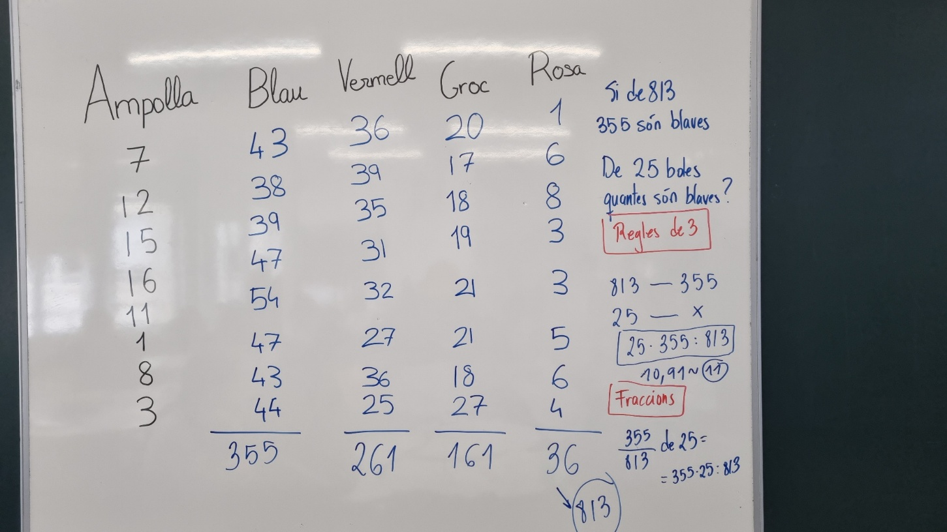
Figure 1 : Example of pooling the bottles with the most frequent blue balls
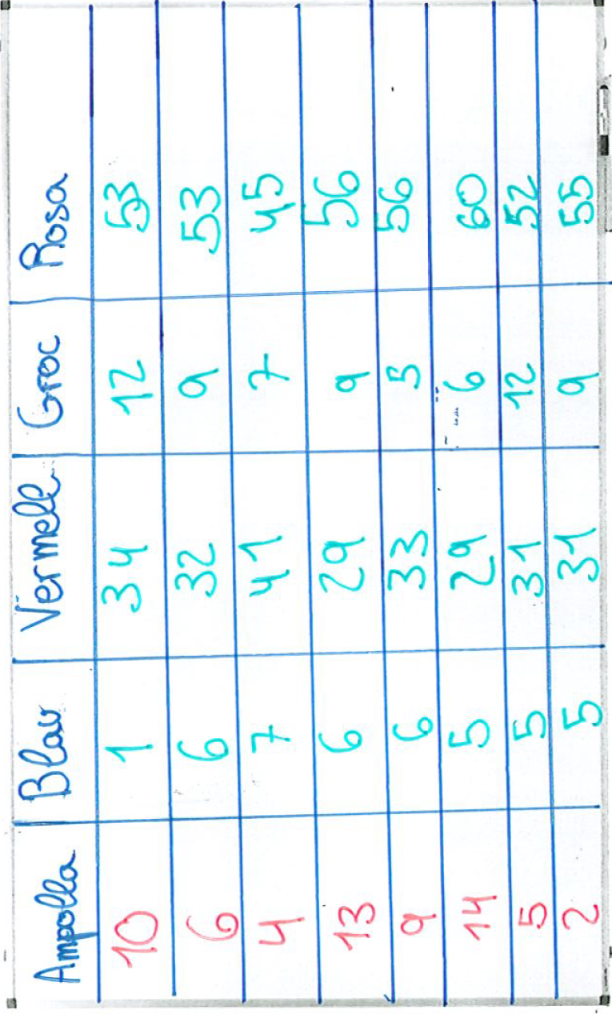
Figure 2 : Example of pooling the bottles with the most frequent pink balls
They will discuss whether they believe this hypothesis is true and how they could validate it.
The teacher will initiate a debate to explore the question: Can we determine if this is the same composition? We hope that ideas such as:
- We could eliminate the bottles that we consider dubious, because they don't look like the rest.
- We could expand the sample just for those questionable bottles.
- We might ask which colors vary the most. If we consider the absolute differences we can see that pink (8-1=7) and blue (54 - 38 = 16). But if we look at it relatively, with respect to the total of each color: pink 7/36 = 19% and blue 16/355 = 4.5%
Finally, the teacher can close the debate by making a joint decision with the students on whether they consider it to be a single bottle or whether they prefer to make subgroups or more visualizations of a bottle.

[5] Validació de dades: ampliació de la mostra 2 0 minutes (End of session 3)

Here we address the question: What results do we obtain if we combine all the data from the bottles that we consider equal?

It is proposed to the teams to investigate whether they would modify their hypothesis by now considering the total collection of all the grouped bottles. Here they do not have to collect any more data, but will put together all the data collected during the last few days by the teams with the same bottle.

At this point, students should be able to give a final hypothesis (and, if enough runs have been made) with great confidence. You may decide to do another sharing session to collect the decisions of the different teams regarding the rounding of decimals that may result from the calculations.

[6] Redacció de l’informe final 6 0 minutes (Session 4)

Let's go back to the initial question: What is the content of the bottle?

Students will have to write a final report [Phase 2 – Final Report] in which they will have to give a complete narration of all the steps followed, paying close attention to the appropriate use of vocabulary. The teacher can decide which elements he indicates to the students to include in this final report. For example:
- How have your hypotheses changed? Have you remained firm in one decision or have you varied?
- What do you think the composition of the bottle is?
- Are you sure of your answer? What makes you think so?
- What would you do to be even safer?
- How did you organize your work? Did you find good ways to collect data? What were the best decisions?

Resources and materials needed/available
Different bottles : In this phase you can decide not to use the bottles, just in case some team decides to do more visualizations because they are not sure that their bottle matches the others.
Phase3 report – Report
Phase3 report – Final report
Class board : Where the teacher will have to write a table with a summary of the hypotheses and results.

Relevant comments for the management of Phase 2
Resisting...
Although it may seem that students are more accepting of the idea of using the rule of three , we avoid introducing it, as it leads to very mechanized justifications that do not encourage reasoning.

